## 

## 

## 

GOODWILL PHARMACY

**-FOR QUALITY MEDICINAL DRUGS**

# Introduction:

This is a Medicine Billing Application by using Python-MYSQL to make this project. We have used Python Module Tkinter to Create GUI and MYSQL Connector to Connect to MYSQL Database.

Here Python-Tkinter Works as a front-end and MYSQL works as a back-end.

# Abstracts:

1. With some Alterations in the code, it can also be used in Hospitals to record Incoming and Outgoing Patients.
2. It can be used in Pharmacies to check the availability of drugs and check the retails of the day. It will help you keep track of the cash flow in your business.
3. It Gets the input medicine name from the Customer, generates a bill, and saves a copy in MYSQL DATABASE.

# Objectives:

1. To Establish a Connection between MYSQL and Python.
2. To prepare GUI for Billing Application
3. To Code for the following functions:-
   * 1. DISPLAYING older bills from Database
     2. ADDING new bills to Database
     3. MODIFY the existing bill from Database
     4. DELETING an Item from the Bill
     5. DELETING an Entire Bill from Database

**Front-End: PYTHON**

We have used Python Tkinter Module to create GUI & Python has a lot of GUI frameworks, but Tkinter is the only framework that’s built into the Python standard library. Tkinter has several strengths.

It’s cross-platform, so the same code works on Windows, macOS, and Linux. Visual elements are rendered using native operating system elements, so applications built with Tkinter look like they belong on the platform where they’re run.

Tkinter is lightweight and relatively painless to use compared to other frameworks. This makes it a compelling choice for building GUI applications in Python, especially for applications where a modern sheen is unnecessary, and the top priority is to build something that’s functional and cross-platform quickly.



**Back-End: MYSQL**

It is open source, Non pirated, reliable, compatible with all major hosting providers, cost-effective, and easy to manage. Many organizations are leveraging the data security and strong transactional support offered by MySQL to secure online transactions and enhance customer interactions.

The primary factor differentiating relational databases from other digital storage lies in how data is organized at a high level. Databases like MySQL contain records in multiple, separate, and highly codified tables, as opposed to a single all-encompassing repository, or collections of semi- or unstructured documents.

This allows RDBMSs to better optimize actions like data retrieval, updating information, or more complex actions like aggregations. A logical model is defined over all of the contents of the database, describing for example the values allowed in individual columns, characteristics of tables and views, or how indices from two tables are related.



**HARDWARE REQUIREMENT:**

* **CPU compatible with your OS(Arm 64-bit, x86 64-bit, etc. Preferably quad-core processor).**
* **Minimum of 4GB of RAM. (8GB is recommended).**
* **Minimum of 16GB of free storage.**

**SOFTWARE REQUIREMENTS:**

* **OS such as Linux, MacOS, Windows, etc.**
* **Python 3.7 version or above.**
* **Python modules such as ‘Tkinter’ and ‘MySQL connector’ which must be installed using a command prompt(on Windows OS) or terminal(on Linux and MacOS).**
* **MySQL database version 5.6, 5.7, 8.0, or greater.**

# Flow chart:

# 

SOURCE CODE:

1. GUI and Python :

# importing all the required packages

from tkinter import *

from tkinter import messagebox, ttk

from database import *

# colors

black = "#000000"

white = "#FFFFFF"

red = "#FF0000"

green = "#00FF00"

blue = "#0066FF"

yellow = "#FFFF00"

cyan = "#00FFFF"

purple = "#A64DFF"

orange = "#FF8533"

# preping a window

root = Tk()

root.title("BILLING APP")

root.configure(background = black)

# setting an icon for the app

icon_image = PhotoImage(file = r"pharmacy icon.png")

root.tk.call('wm', 'iconphoto', root._w, icon_image)

# clearing all the widgets from the page to make room for the next page

def clear_page():

for widget in root.grid_slaves():

widget.destroy()

# command for the exit button

def exit():

global exit_window

exit_window = Tk()

exit_window.title("EXIT")

exit_label = Label(exit_window, text = "DO YOU WANT TO EXIT?")

exit_label.grid(row = 0, column = 0, padx = 2, pady = 2, columnspan = 2)

yes_button = Button(exit_window, text = "YES", borderwidth = 2, command = lambda : destroy_app(1))

yes_button.grid(row = 1, column = 0, padx = 2, pady = 2)

no_button = Button(exit_window, text = "NO", background = black, foreground = white, borderwidth = 2, command = lambda : destroy_app(0))

no_button.grid(row = 1, column = 1, padx = 2, pady = 2)

# this function destroys the eintire app by closing the all the windows and quiting

def destroy_app(a):

global root

if a == 1:

root.destroy()

exit_window.destroy()

quit()

else:

exit_window.destroy()

# destroying all the widgets in the left side frame

def clear_left_frame():

for widgets in left_side_frame.winfo_children():

widgets.destroy()

# we set the output_box state to disabled so that the user can't change anything in the output box

# It is only used to see the output bill

# changing the state from disabled to normal so that the system can edit the content in the output box

def clear_a_line_in_text_box(line):

output_box.config(state = NORMAL)

output_box.delete(float(line), float(line + 1))

output_box.config(state = DISABLED)

def clear_the_entire_text_box():

output_box.config(state = NORMAL)

output_box.delete(1.0, END)

output_box.config(state = DISABLED)

def clear_entire_text_box_from_start_line(line):

output_box.config(state = NORMAL)

output_box.delete(float(line), END)

output_box.config(state = DISABLED)

def display_in_output_box(string, position = -1):

output_box.config(state = NORMAL)

output_box.insert(f"end {position} chars", string)

output_box.config(state = DISABLED)

def get_entire_text_box():

return output_box.get(1.0, END)

# login gui for the user with login button.

def login_gui():

# entry boxes for username and password and passing the parameters to the button function

# this is for clearing the page when the login button is pressed

try:

clear_page()

except:

pass

username_name_label = Label(root, text = "Username:", foreground = white, background = black)

username_name_label.grid(row = 0, column = 0, padx = 4, pady = 4, sticky = EW)

global username_name_entry

username_name_entry = Entry(root)

username_name_entry.grid(row = 0, column = 1, padx = 4, pady = 4)

password_label = Label(root, text = "Password:", foreground = white, background = black)

password_label.grid(row = 1, column = 0, padx = 4, pady = 4, sticky = EW)

global password_entry

password_entry = Entry(root, show = "⚹")

password_entry.grid(row = 1, column = 1, padx = 4, pady = 4)

login_button = Button(root, text = "LOGIN", foreground = black, background = green ,command = lambda : login_button_func(username_name_entry.get(), password_entry.get()))

login_button.grid(row = 3, column = 1, padx = 4, pady = 4, sticky = E)

# login code to execute to authenticate the username and the password entered by the user

def login_button_func(username_input, password_input):

if authentication(username_input, password_input):

# savind the username to know who made pa bill

global username

username = username_name_entry.get()

# wiping the entire page and changing the gui to the mainpage

clear_page()

# creating two frames to sperate the output box and all the buttons and lables

global left_side_frame

global right_side_frame

left_side_frame = Frame(root, background = black)

right_side_frame = Frame(root, background = black)

left_side_frame.grid(row=0, column=0)

right_side_frame.grid(row=0, column=1)

main_page()

else:

# error pop up,clear the entry widgets ask the user to re-enter all the creadentials

messagebox.showerror("ACCESS DENIED!!","Wrong username or password entered!")

password_entry.delete(0, END)

username_name_entry.delete(0, END)

# creating main page where user can access all the commands like "new bill"

def main_page():

clear_left_frame()

# clear_the_entire_text_box()

# getting data of main_bill from database.

global database_bill_no

database_bill_no = get_bill_no()

global extra_bill_no

extra_bill_no = [num for num in range(1, 10001) if num not in database_bill_no]

global main_bill_raw

main_bill_raw = get_main_bill()

# LEFT FRAME

home_label = Label(left_side_frame, text = "HOME", width = 30, height = 5, background = black, foreground = orange, font = (100))

home_label.grid(row = 0, column = 0 , padx = 10 , pady = 20, sticky = EW)

show_bill_button = Button(left_side_frame, text = "SHOW A BILL", width = 25, background = green, foreground = black, command = lambda : show_bill_page())

show_bill_button.grid(row = 1, column = 0, padx = 10, pady = 20)

add_bill_button = Button(left_side_frame, text = "ADD A NEW BILL" , width = 25, background = cyan, foreground = black, command = lambda : add_bill_page())

add_bill_button.grid(row = 2, column = 0, padx = 10, pady = 20)

modify_bill_button = Button(left_side_frame, text = "MODIFY A BILL", width = 25, background = orange, foreground = black, command = lambda : modify_bill_page())

modify_bill_button.grid(row = 3, column = 0, padx = 10, pady = 20)

delete_bill_button = Button(left_side_frame, text = "DELETE A BILL", width = 25, background = red, foreground = black, command = lambda : delete_bill_page())

delete_bill_button.grid(row = 4, column = 0, padx = 10, pady = 20)

exit_button = Button(left_side_frame, text = "EXIT", background = red , foreground = black, command = lambda : exit())

exit_button.grid(row = 5, column = 0, sticky = W, padx = 10, pady = 20)

log_out_button = Button(left_side_frame, text = "LOGOUT", background = purple, foreground = black, command = lambda : login_gui())

log_out_button.grid(row = 5, column = 0, sticky = E, padx = 10, pady = 20)

# RIGHT FRAME

global output_box

output_box = Text(right_side_frame, width = 95, height = 30, background = white, foreground = black, state = DISABLED)

output_box.grid(column = 0, row = 0, padx = 5, pady = 5)

# show the main bill in the output box

text = """+-------------+---------------------------+-----------------+--------------+-----------------+

| BILL NUMBER | CUSTOMER NAME | PHONE NO. | TOTAL | BILLER NAME |

+-------------+---------------------------+-----------------+--------------+-----------------+\n"""

for items in main_bill_raw:

text += f"| {items[0]}{((11 - len(str(items[0]))) * ' ')} "

text += f"| {items[1]}{((25 - len(str(items[1]))) * ' ')} "

text += f"| {items[2]}{((15 - len(str(items[2]))) * ' ')} "

text += f"| {items[3]}{((12 - len(str(items[3]))) * ' ')} "

text += f"| {items[4]}{((15 - len(str(items[4]))) * ' ')} "

text += "|\n|-------------+---------------------------+-----------------+--------------+-----------------|\n"

text = text[0:len(text)-95]

text += "+-------------+---------------------------+-----------------+--------------+-----------------+"

display_in_output_box(text)

# this page is to show the desired bill entered by the user

def show_bill_page():

# destroying all widgets in left frame to make room for new widgets

clear_left_frame()

show_bill_page_label = Label(left_side_frame, text = "SHOW BILL", background = black, foreground = orange, font = (100))

show_bill_page_label.grid(row = 0, column = 0, columnspan = 3, padx = 10, pady = 20, sticky = N)

input_label = Label(left_side_frame, text = "Enter the bill number to display", background = black, foreground = white)

input_label.grid(row = 1, column = 1, padx = 5, pady = 15, sticky = EW)

global select_number

select_number = StringVar()

input_bill_no = ttk.Combobox(left_side_frame, textvariable = select_number, values = database_bill_no, state = "readonly")

input_bill_no.grid(row = 2,column=1, padx = 5, pady = 15, sticky = EW)

display_button = Button(left_side_frame,text = "DISPLAY BILL",background = green ,foreground = black, command = lambda : show_bill_in_text_box())

display_button.grid(row = 3,column = 1, padx = 5, pady = 11, sticky = EW)

print_button = Button(left_side_frame, text = "PRINT BILL", background = blue, foreground = black, command = lambda : print_bill())

print_button.grid(row = 4, column = 1, padx = 5, pady = 15 ,sticky = EW)

exit_button = Button(left_side_frame, text = "EXIT", background = red , foreground = black, command = lambda : exit())

exit_button.grid(row = 4, column = 0, padx = 5, pady = 15, sticky = W)

back_button = Button(left_side_frame, text = "BACK", background = purple, foreground = black, command = lambda : main_page())

back_button.grid(row = 4, column = 2, padx = 5, pady = 15, sticky = E)

# validates whether the given bill is there in the database and the entered bill is an integer

def show_bill_in_text_box():

try:

global display_bill_no

display_bill_no = int(select_number.get())

global display_bill

display_bill = get_customer_bill(display_bill_no)

details = get_customer_name_and_phone_number(display_bill_no)

# SHOWING THE BILL

text = f"CUSTOMER NAME : {details[1]}\nPHONE NUMBER : {details[2]}\nBILL NUMBER : {display_bill_no}\nBILLER NAME : {details[4]}\n\n"

text += """+------+-------------------------------------+--------+-----+-----------+

| S.NO | PRODUCT NAME | PRICE | QTY | TOTAL |

+------+-------------------------------------+--------+-----+-----------+\n"""

grand_tot = 0

for i in range(len(display_bill)):

text += f"| {i + 1}.{((3 - len(str(i + 1))) * ' ')} "

text += f"| {display_bill[i][0]}{((35 - len(str(display_bill[i][0]))) * ' ')} "

text += f"| {display_bill[i][1]}{((6 - len(str(display_bill[i][1]))) * ' ')} "

text += f"| {display_bill[i][2]}{((3 - len(str(display_bill[i][2]))) * ' ')} "

text += f"| {display_bill[i][3]}{((9 - len(str(display_bill[i][3]))) * ' ')} "

text += "|\n|------+-------------------------------------+--------+-----+-----------|\n"

grand_tot += display_bill[i][3]

text = text[0:len(text)-75]

text += f"""\n+------+-------------------------------------+--------+-----+-----------+

| GRAND TOTAL : {grand_tot}{((10 - len(str(grand_tot))) * ' ')}|

+-----------------------------------------------------------------------+"""

# making room for the desired output

clear_the_entire_text_box()

# displaying the bill in the output box

display_in_output_box(text)

except:

pass

def print_bill():

file = open(f"BILL {display_bill_no}", "w")

# pharmacy name

# file.write(f"")

file.write(get_entire_text_box())

file.close()

def add_bill_page():

# destroying all the widgets in the left side frame

clear_left_frame()

# displaying all the widgets for getting customer name, phone number, bill number

add_bill_page_label = Label(left_side_frame, text = "ADD A NEW BILL", background = black, foreground = orange, font = (100))

add_bill_page_label.grid(row = 0, column = 0, columnspan = 2, padx = 10, pady = 20, sticky = N)

label_customer_name = Label(left_side_frame, text = "Customer Name:", foreground = white, background = black)

label_customer_name.grid(row = 1, column = 0, padx = 10, pady = 20, sticky = NS)

global customer_name_entry

customer_name_entry = Entry(left_side_frame)

customer_name_entry.grid(row = 1, column = 1, padx = 10, pady = 20)

label_phone_number = Label(left_side_frame, text = "Phone Number:", foreground = white, background = black)

label_phone_number.grid(row = 2, column = 0, padx = 10, pady = 20, sticky = NS)

global phone_number_entry

phone_number_entry = Entry(left_side_frame)

phone_number_entry.grid(row = 2, column = 1, padx = 10, pady = 20)

create_new_bill_button = Button(left_side_frame, text = "CREATE NEW BILL", background = green, foreground = black, command = lambda : add_validation())

create_new_bill_button.grid(row = 4, column = 0, columnspan = 2, padx = 10, pady = 20)

exit_button = Button(left_side_frame, text = "EXIT", background = red , foreground = black, command = lambda : exit())

exit_button.grid(row = 5, column = 0, sticky = W, padx = 10, pady = 20)

back_button = Button(left_side_frame, text = "BACK", background = purple, foreground = black, command = lambda : main_page())

back_button.grid(row = 5, column = 1, sticky = E, padx = 10, pady = 20)

def add_validation():

# this function is to validate whether the given credentials are correct

global customer_name

global phone_number

global bill_number

customer_name = customer_name_entry.get().lstrip().rstrip()

phone_number = phone_number_entry.get().lstrip().rstrip()

bill_number = extra_bill_no.pop(0)

message = ""

# making sure the given credentials are of correct length and data type

if str(bill_number).isnumeric() == False or bill_number in database_bill_no or len(customer_name) > 15 or len(str(bill_number)) > 10 or len(phone_number) > 15 or customer_name == "" or phone_number == "":

if bill_number in database_bill_no:

message += "# Bill no. already exist!\n"

if len(customer_name) > 15:

message += "# Customer name has greater than 15 characters!\n"

if len(str(bill_number)) > 10:

message += "# Bill no. has greater than 10 characters!\n"

if len(phone_number) > 15:

message += "# Phone no. has greater than 15 characters!"

# informing user about the invalid input given

messagebox.showwarning(title = "INVALID INPUTS!!", message = message)

else:

# next operation page

customer_name = customer_name.title()

add_modify_operation_page("add")

# this page is used by both add and modify section of code

# with few alteration we can change the code by passing different parameter

def add_modify_operation_page(add_or_modify):

# cleaning the left frame to add new widgets and clearing the right output textbox to

# display the bill items and list them

clear_left_frame()

clear_the_entire_text_box()

# widgets for left frame

add_bill_page_label = Label(left_side_frame, text = "ADD A NEW BILL", background = black, foreground = orange, font = (100))

add_bill_page_label.grid(row = 0, column = 0, columnspan = 2, padx = 10, pady = 15, sticky = N)

label_product_name = Label(left_side_frame, text = "Product name:", foreground = white, background = black)

label_product_name.grid(row = 1, column = 0, padx = 10 , pady = 15)

global entry_product_name

entry_product_name = Entry(left_side_frame)

entry_product_name.grid(row = 1, column = 1, padx = 10 , pady = 15)

label_product_price = Label(left_side_frame, text = "Product Price:", foreground = white, background = black)

label_product_price.grid(row = 2, column = 0, padx = 10 , pady = 15)

global entry_product_price

entry_product_price = Entry(left_side_frame)

entry_product_price.grid(row = 2, column = 1, padx = 10 , pady = 15)

label_product_quantity = Label(left_side_frame, text = "Quantity:", foreground = white, background = black)

label_product_quantity.grid(row = 3, column = 0, padx = 10 , pady = 15)

global entry_product_quantity

entry_product_quantity = Entry(left_side_frame)

entry_product_quantity.grid(row = 3, column = 1, padx = 10 , pady = 15)

add_product_button = Button(left_side_frame, text = "ADD PRODUCT", foreground = black, background = green, command = lambda : add_product_function_validation())

add_product_button.grid(row = 4, column = 0, columnspan = 2, sticky = EW, padx = 10 , pady = 15)

delete_product_label = Label(left_side_frame, text = "Enter the S.No to remove :", foreground = white, background = black)

delete_product_label.grid(row = 5, column = 0, columnspan = 2, sticky = W, padx = 10 , pady = 15)

global delete_product_entry

delete_product_entry = Entry(left_side_frame, width = 10)

delete_product_entry.grid(row = 5, column = 0, columnspan = 2, sticky = E, padx = 10 , pady = 15)

delete_product_button = Button(left_side_frame, text = "DELETE PRODUCT", foreground = black, background = cyan, command = lambda : delete_an_item(delete_product_entry.get()))

delete_product_button.grid(row = 6, column = 0, columnspan = 2, sticky = EW, padx = 10 , pady = 15)

save_button = Button(left_side_frame, text = "SAVE BILL", width = 5, foreground = black, background = orange, command = lambda : save_bill_database())

save_button.grid(row = 7, column = 0, columnspan = 2, padx = 10, pady = 15, sticky = EW)

exit_button = Button(left_side_frame, text = "EXIT", background = red , foreground = black, command = lambda : exit())

exit_button.grid(row = 8, column = 0, padx = 10, pady = 15, sticky = W)

back_button = Button(left_side_frame, text = "BACK", background = purple, foreground = black, command = lambda : back_button_validation())

back_button.grid(row = 8, column = 1, padx = 10, pady = 15, sticky = E)

# preparing for the output box

global text

text = """+------+-------------------------------------+--------+-----+-----------+

| S.NO | PRODUCT NAME | PRICE | QTY | TOTAL |

+------+-------------------------------------+--------+-----+-----------+\n"""

global serial_no

global grand_total

global products

global price

global quantity

global total

serial_no, grand_total, products, price, quantity, total = 0, 0, [], [], [], []

# by passing different parameter we can choose between modify and add functions

if add_or_modify == "modify":

customer_bill = get_customer_bill(bill_number)

for i in range(len(customer_bill)):

text += f"| {i + 1}.{((3 - len(str(i + 1))) * ' ')} "

text += f"| {customer_bill[i][0]}{((35 - len(str(customer_bill[i][0]))) * ' ')} "

text += f"| {customer_bill[i][1]}{((6 - len(str(customer_bill[i][1]))) * ' ')} "

text += f"| {customer_bill[i][2]}{((3 - len(str(customer_bill[i][2]))) * ' ')} "

text += f"| {customer_bill[i][3]}{((9 - len(str(customer_bill[i][3]))) * ' ')} "

text += "|\n|------+-------------------------------------+--------+-----+-----------|\n"

serial_no += 1

grand_total += customer_bill[i][1] * customer_bill[i][2]

products.append(customer_bill[i][0])

price.append(customer_bill[i][1])

quantity.append(customer_bill[i][2])

total.append(customer_bill[i][3])

text = text[0:len(text)-74]

text += f"""+------+-------------------------------------+--------+-----+-----------+

| GRAND TOTAL : {grand_total}{((10 - len(str(grand_total))) * ' ')}|

+-----------------------------------------------------------------------+"""

display_in_output_box(text)

# this remainds the user to save the bill before leaving to home page

# there is a function in save_bill command to implement.

global remind_save_bill

remind_save_bill = False

# validates whether the entered credentials is valid

def add_product_function_validation():

global product_name

global product_price

global product_quantity

product_name = entry_product_name.get().lstrip().rstrip().title()

product_price = entry_product_price.get().lstrip().rstrip()

product_quantity = entry_product_quantity.get().lstrip().rstrip()

global grand

grand = True

text = ""

if len(str(serial_no)) > 4 or len(product_name) > 35 or product_price.isnumeric() == False or len(str(product_price)) > 6 or product_quantity.isnumeric() == False or len(str(product_quantity)) > 3 or (int(grand_total) + (int(product_price) * (int(product_quantity)))) > 9999999999:

if len(str(serial_no)) > 4:

text += "# Only 9999 products can be stored in a bill.\n"

if len(product_name) > 35:

text += f"# Reduce the name of product by {len(product_name) - 35} characters.\n"

if product_price.isnumeric() == False:

text += "# Price cannot take alphabets of any special characters.\n"

grand = False

else:

product_price = int(product_price)

if len(str(product_price)) > 6:

text += "# Price can take value upto 9,99,999.\n"

if product_quantity.isnumeric() == False:

text += "# Price cannot take alphabets of any special characters.\n"

grand = False

else:

product_quantity = int(product_quantity)

if len(str(product_quantity)) > 3:

text += "# Price can take value upto 999.\n"

if grand_total + (product_price * product_quantity) > 9999999999:

text += "# Grand total cannot take value greater than 999,99,99,999. Click save bill and make a new bill.\n"

# informing the user about the error

messagebox.showerror("ERROR", text)

else:

add_product_function()# checking whether the given bill no is there in database

def add_product_function():

global serial_no, grand_total, product_quantity, product_price

# type casting the required variables

product_quantity = int(product_quantity)

product_price = int(product_price)

# adding all the necessary details to the list

products.append(product_name)

price.append(product_price)

quantity.append(product_quantity)

total_price = product_price * product_quantity

total.append(total_price)

serial_no += 1

grand_total += total_price

# clearing the required lines to accommodate for the added item

if serial_no > 2:

clear_a_line_in_text_box(serial_no * 2 + 1)

clear_a_line_in_text_box(serial_no * 2 + 1)

clear_a_line_in_text_box(serial_no * 2 + 1)

else:

clear_a_line_in_text_box(serial_no + 3)

clear_a_line_in_text_box(serial_no + 3)

clear_a_line_in_text_box(serial_no + 3)

# making text for displaying output

text = ""

if serial_no > 1:

text += "\n|------+-------------------------------------+--------+-----+-----------|"

text += f"\n| {serial_no}.{((3 - len(str(serial_no))) * ' ')} "

text += f"| {product_name}{((35 - len(str(product_name))) * ' ')} "

text += f"| {product_price}{((6 - len(str(product_price))) * ' ')} "

text += f"| {product_quantity}{((3 - len(str(product_quantity))) * ' ')} "

text += f"| {total_price}{((9 - len(str(total_price))) * ' ')} |"

display_in_output_box(text)

text = f"""\n+------+-------------------------------------+--------+-----+-----------+

| GRAND TOTAL : {grand_total}{((10 - len(str(grand_total))) * ' ')}|

+-----------------------------------------------------------------------+"""

display_in_output_box(text)

# changing the value to true to remind the user to save bill

global remind_save_bill

remind_save_bill = True

entry_product_name.delete(0, END)

entry_product_price.delete(0, END)

entry_product_quantity.delete(0, END)

def delete_an_item(s_number):

global serial_no

global grand_total

try:

# making the entered number positive even if the entered number is negative

s_number = int(s_number).__abs__()

if s_number <= serial_no:

# clearing the line according to the serial no entered by the user

if s_number < 2 :

clear_entire_text_box_from_start_line(3 + s_number)

else:

clear_entire_text_box_from_start_line((s_number * 2) + 2)

# deleting the items from the lists

del products[s_number - 1]

del price[s_number - 1]

del quantity[s_number - 1]

grand_total -= total[s_number - 1]

del total[s_number - 1]

serial_no -= 1

# preparing new test for output

text = "\n"

try:

for i in range(s_number - 1, len(products)):

text += f"| {i + 1}.{((3 - len(str(i + 1))) * ' ')} "

text += f"| {products[i]}{((35 - len(str(products[i]))) * ' ')} "

text += f"| {price[i]}{((6 - len(str(price[i]))) * ' ')} "

text += f"| {quantity[i]}{((3 - len(str(quantity[i]))) * ' ')} "

text += f"| {total[i]}{((9 - len(str(total[i]))) * ' ')} "

text += "|\n|------+-------------------------------------+--------+-----+-----------|\n"

except:

pass

text += f"""| GRAND TOTAL : {grand_total}{((10 - len(str(grand_total))) * ' ')}|

+------+-------------------------------------+--------+-----+-----------+"""

display_in_output_box(text)

global remind_save_bill

remind_save_bill = True

else:

messagebox.showerror("ERROR", "ENTERED NUMBER EXCEEDS SERIAL NUMBER")

delete_product_entry.delete(0, END)

except:

messagebox.showerror("ERROR", "CANNOT FIND THE SERIAL NUMBER TO DELETE")

delete_product_entry.delete(0, END)

delete_product_entry.delete(0, END)

# validate for back button

def back_button_validation():

global remind_save_bill

if remind_save_bill:

messagebox.showwarning("WARNING", "BILL IS NOT SAVED IN THE DATABASE!\nCLICK 'SAVE BILL' TO SAVE")

else:

main_page()

def save_bill_database():

global database_bill_no

if bill_number not in database_bill_no:

create_a_new_bill(bill_number, customer_name, phone_number, grand_total, username)

database_bill_no = get_bill_no()

else:

delete_records(bill_number)

save_bill(bill_number, products, price, quantity, total, grand_total)

global remind_save_bill

remind_save_bill = False

def modify_bill_page():

# clearing left frame for new widgets

clear_left_frame()

modify_bill_page_label = Label(left_side_frame, text = "MODIFY BILL", background = black, foreground = orange, font = (100))

modify_bill_page_label.grid(row = 0, column = 0, columnspan = 3, padx = 10, pady = 20, sticky = N)

modify_input_label = Label(left_side_frame, text = "Select the bill number to modify",background = black, foreground = white)

modify_input_label.grid(row = 1,column = 1, padx = 5,pady = 15, sticky = EW)

global modify_number

modify_number = StringVar()

modify_input_bill_no = ttk.Combobox(left_side_frame, textvariable = modify_number, values = database_bill_no, state = "readonly")

modify_input_bill_no.grid(row = 2,column = 1, padx = 5,pady = 15, sticky = EW)

modify_button = Button(left_side_frame,text = "MODIFY BILL",background = orange ,foreground = black, command = lambda : modify_bill_validation())

modify_button.grid(row = 3,column = 1, padx = 5,pady = 15, sticky = EW)

exit_button = Button(left_side_frame, text = "EXIT", background = red , foreground = black, command = lambda : exit())

exit_button.grid(row = 4, column = 0, padx = 5, pady = 15, sticky = W)

back_button = Button(left_side_frame, text = "BACK", background = purple, foreground = black, command = lambda : main_page())

back_button.grid(row = 4, column = 2, padx = 5, pady = 15, sticky = E)

# validation for modify page

def modify_bill_validation():

try:

modify_bill_number = int(modify_number.get())

global bill_number

bill_number = modify_bill_number

add_modify_operation_page("modify")

except:

pass

def delete_bill_page():

# clearing left frame for new widgets

clear_left_frame()

delete_bill_page_label = Label(left_side_frame, text = "DELETE BILL", background = black, foreground = orange, font = (100))

delete_bill_page_label.grid(row = 0, column = 0, columnspan = 3, padx = 10, pady = 20, sticky = N)

del_input_label = Label(left_side_frame, text = "Select the bill number to delete",background = black, foreground = white)

del_input_label.grid(row = 1, column = 1, padx = 5,pady = 15, sticky = EW)

global delete_number

delete_number = StringVar()

del_input_bill_no = ttk.Combobox(left_side_frame, textvariable = delete_number, values = database_bill_no, state = "readonly")

del_input_bill_no.grid(row = 2, column = 1, padx = 5,pady = 15, sticky = EW)

delete_button = Button(left_side_frame,text = "DELETE BILL",background = cyan ,foreground = black, command = lambda : delete_bill_validation())

delete_button.grid(row = 3,column = 1, padx = 5,pady = 15, sticky = EW)

exit_button = Button(left_side_frame, text = "EXIT", background = red , foreground = black, command = lambda : exit())

exit_button.grid(row = 4, column = 0, padx = 5, pady = 15, sticky = W)

back_button = Button(left_side_frame, text = "BACK", background = purple, foreground = black, command = lambda : main_page())

back_button.grid(row = 4, column = 2, padx = 5, pady = 15, sticky = E)

def delete_bill_validation():

try:

delete_bill_number = int(delete_number.get())

delete_customer_bill(delete_bill_number)

# clearing the output box for main page

clear_the_entire_text_box()

main_page()

except:

pass

login_gui()

root.mainloop()

1. DATABASE ( MYSQL):

import mysql.connector

#authentication for the billing person

def authentication(username, password):

try:

global mysql_con

mysql_con = mysql.connector.connect(host = "localhost", user = username, password = password, db = "billing_app")

global mysql_cursor

mysql_cursor = mysql_con.cursor()

return True

except:

return False

def get_bill_no():

mysql_cursor.execute("SELECT bill_no FROM main_bill")

tmp_list = []

for number in mysql_cursor.fetchall():

tmp_list.append(number[0])

return tmp_list

def get_main_bill():

mysql_cursor.execute("SELECT * FROM main_bill")

return mysql_cursor.fetchall()

def create_a_new_bill(bill_no, customer, phone, total, biller):

mysql_cursor.execute(f"CREATE TABLE bill_{bill_no}(item_name varchar(35), price int, quantity int, total int)")

mysql_con.commit()

mysql_cursor.execute(f"INSERT INTO main_bill VALUES({bill_no}, '{customer}', '{phone}', '{total}', '{biller}')")

mysql_con.commit()

def get_customer_bill(bill_no):

mysql_cursor.execute(f"SELECT * FROM bill_{bill_no}")

return mysql_cursor.fetchall()

def get_customer_name_and_phone_number(bill_no):

mysql_cursor.execute(f"SELECT * FROM main_bill where bill_no = {bill_no}")

return mysql_cursor.fetchall()[0]

def delete_customer_bill(bill_no):

mysql_cursor.execute(f"DROP TABLE bill_{bill_no}")

mysql_cursor.execute(f"DELETE FROM main_bill where bill_no = {bill_no}")

mysql_con.commit()

def save_bill(bill_no, products, price, quantity, total, grand_total):

for i in range(len(products)):

mysql_cursor.execute(f"INSERT INTO bill_{bill_no} VALUES('{products[i]}', {price[i]}, {quantity[i]}, {total[i]})")

mysql_con.commit()

mysql_cursor.execute(f"UPDATE main_bill SET total = {grand_total} WHERE bill_no = {bill_no}")

mysql_con.commit()

def delete_records(bill_no):

mysql_cursor.execute(f"DELETE FROM bill_{bill_no}")

mysql_con.commit()

OUTPUT SCREENSHOTS:

i) Enter the Username and Password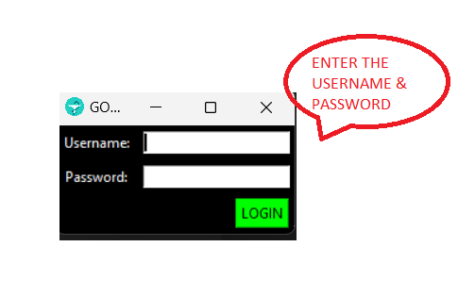

ii) The window here, is used to access the bill, i.e To DELETE, ADD, SHOW & MODIFY

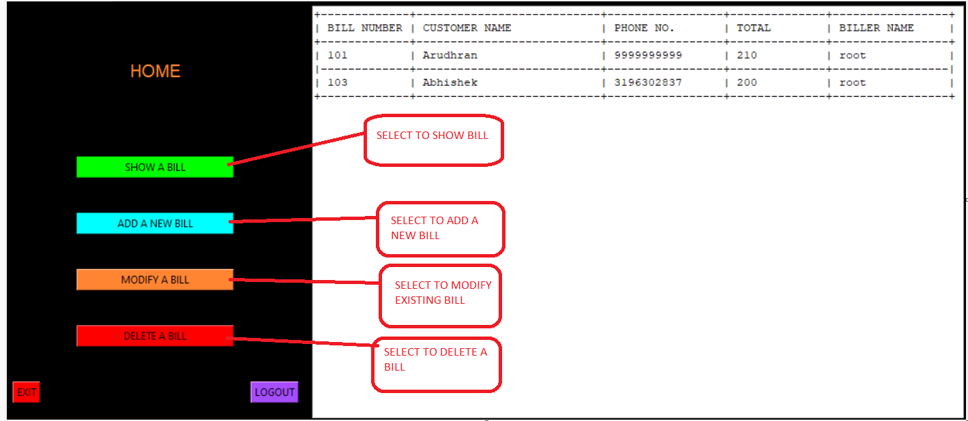

iii) To Show bills:

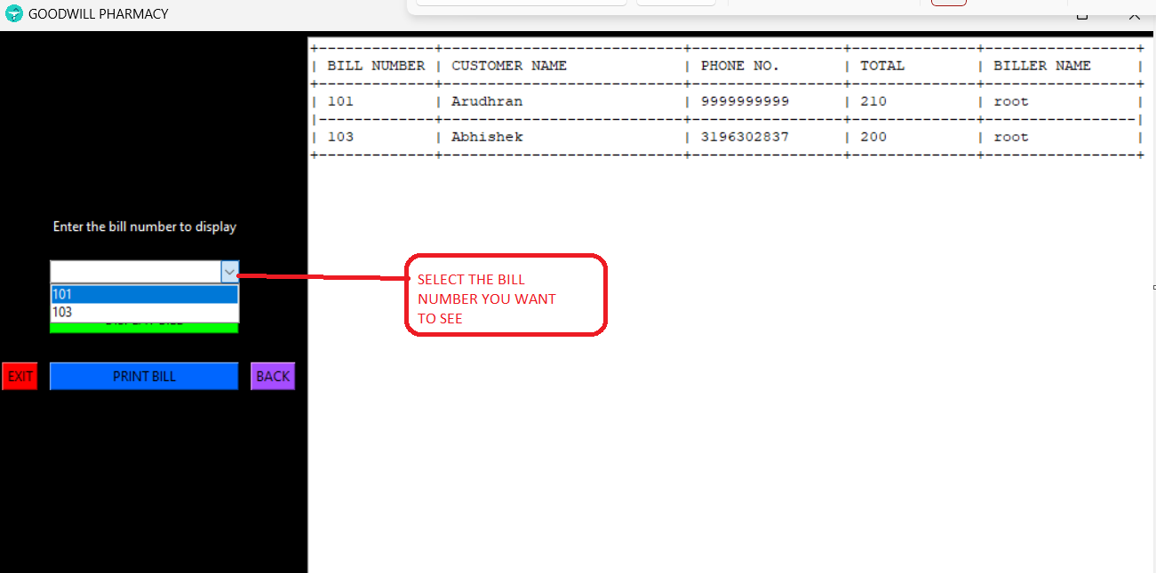

iv) a) To Add a new bill:

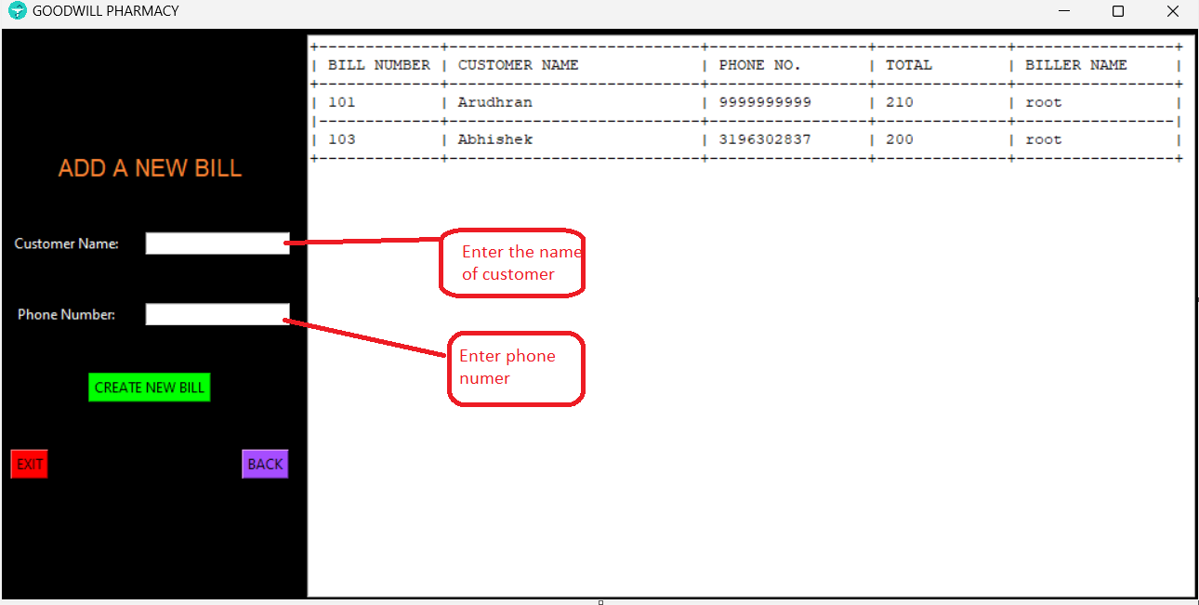

b) Add the product details:

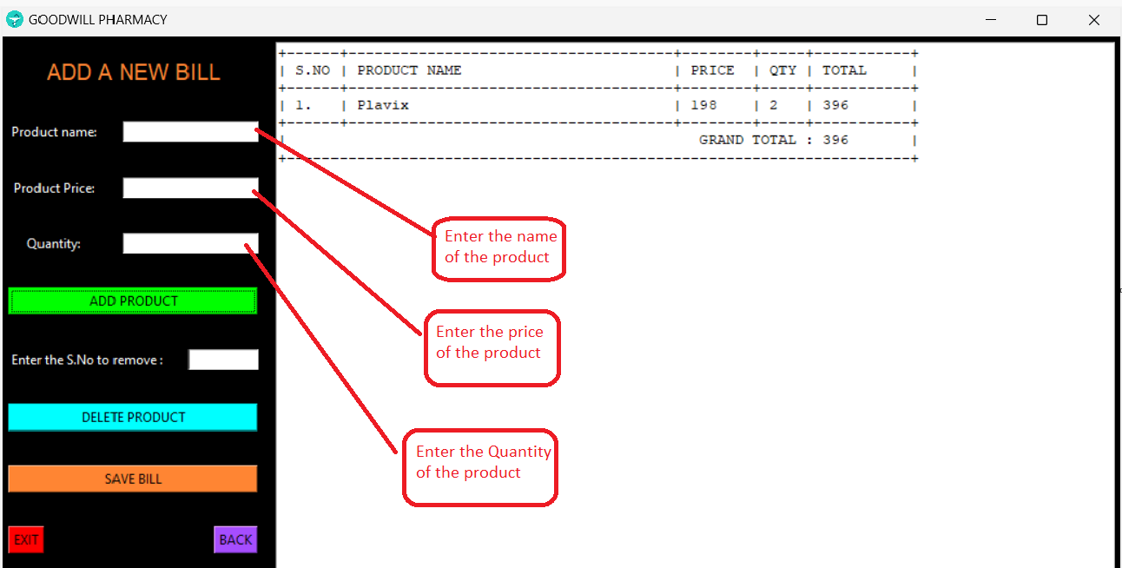

v) To Modify the Bill:

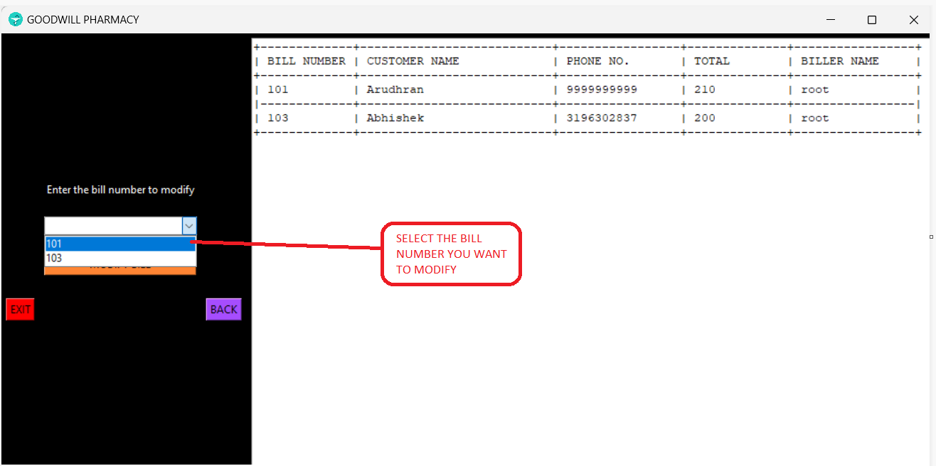

vi) To delete the bill:

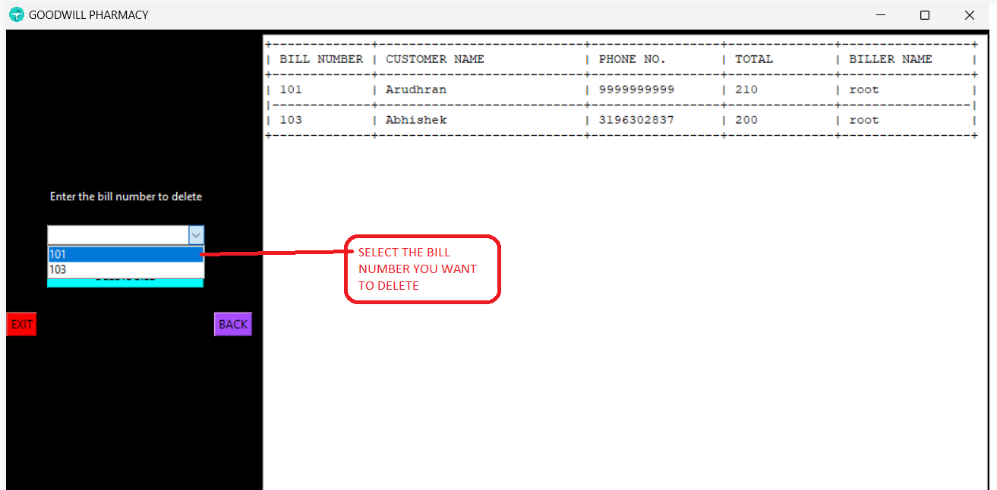

DATABASE OUTPUT SCREENSHOTS:

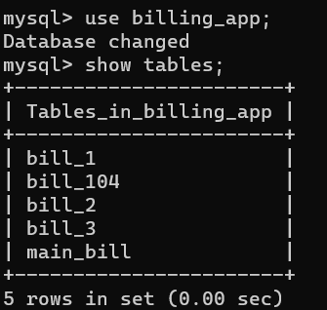

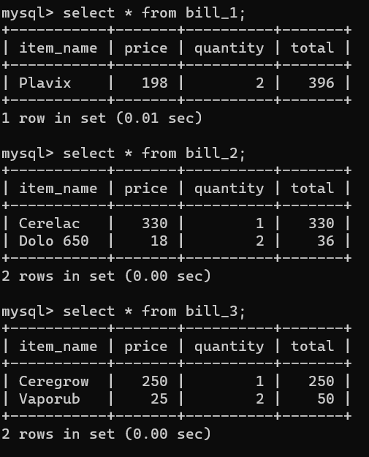

**BIBLIOGRAPHY:**

* John Elder - (codemy.com)
* W3 Schools - (w3schools.com)
* Stack Overflow - (stackoverflow.com)
* Geeks For Geeks - (geeksforgeeks.org)

**CONCLUSION:**

**We would like to take this opportunity to thank our teachers for their guidance and letting us accomplish this feat. We also learned the values that other members taught us in this process. Thank you!!**

